* + **Snapshot Shows the Bridge lifting down:**

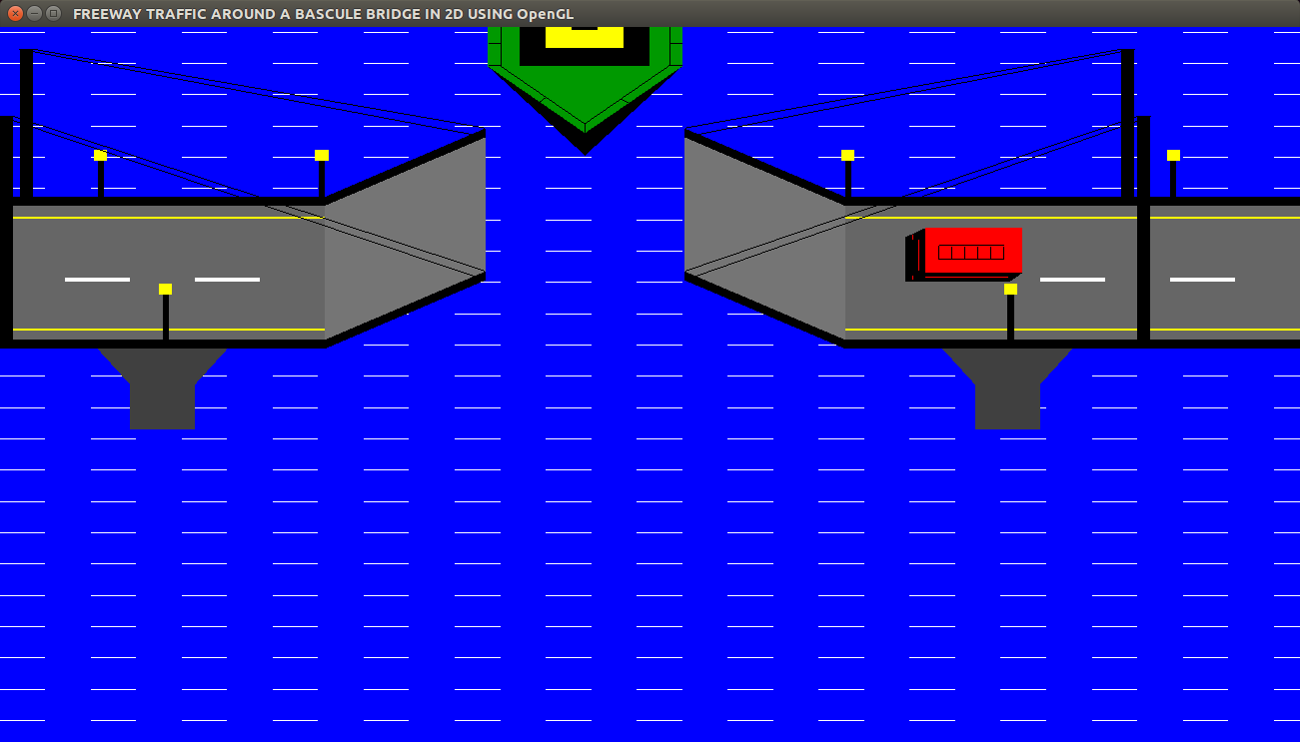

Fig 6.8 Downward lifting of the Bridge.

* + **Snapshot Shows the Vehicle Crossing Over the Bridge**

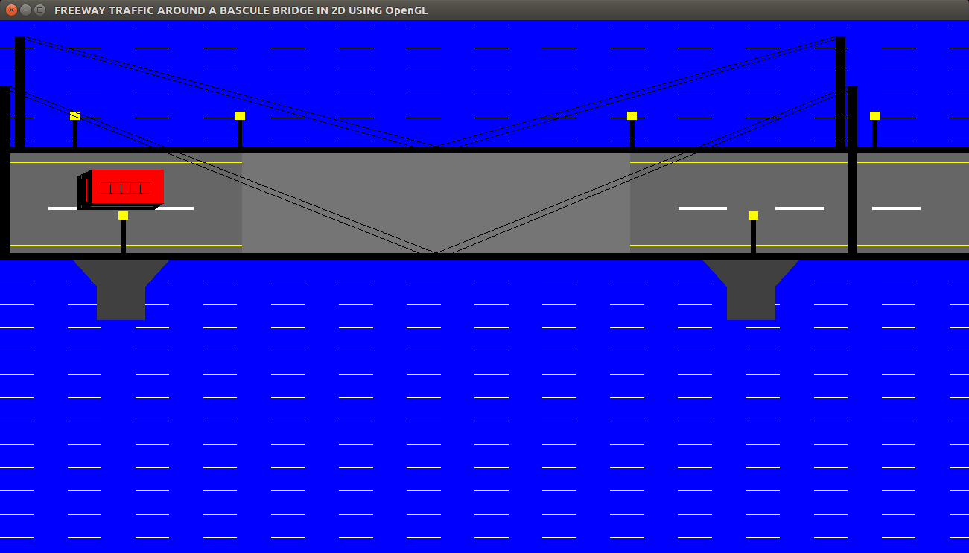

Fig 6.9 Vehicle crossing over the Bridge